EXP 3 K MANOJ KIRAAN

240701305

REPORTS IN ZOHO CREATOR

AIM
To create different types of reports in Zoho Creator for viewing, organizing, and analyzing the student information stored in the Student Management System forms.

PROCEDURE
- Open the Student Management System application in Zoho Creator.
- Create reports for the Student Profile, Academic, Guardian Contact, and Course Enrollment forms.
- Create suitable report types such as:
○ List Report – to display student records in tabular format.
○ Kanban Report – to categorize students based on suitable fields such as Department or Semester.
○ Calendar Report – to display course enrollment dates.
○ Pivot Table Report – to analyze students based on Department, Semester, or Course.
○ Pivot Chart Report – to graphically represent academic or enrollment data.
- Configure the required fields and filters for each report.
- Add sample records and verify that the reports display the correct information.
- Preview all reports and check their functionality.

OUTPUT

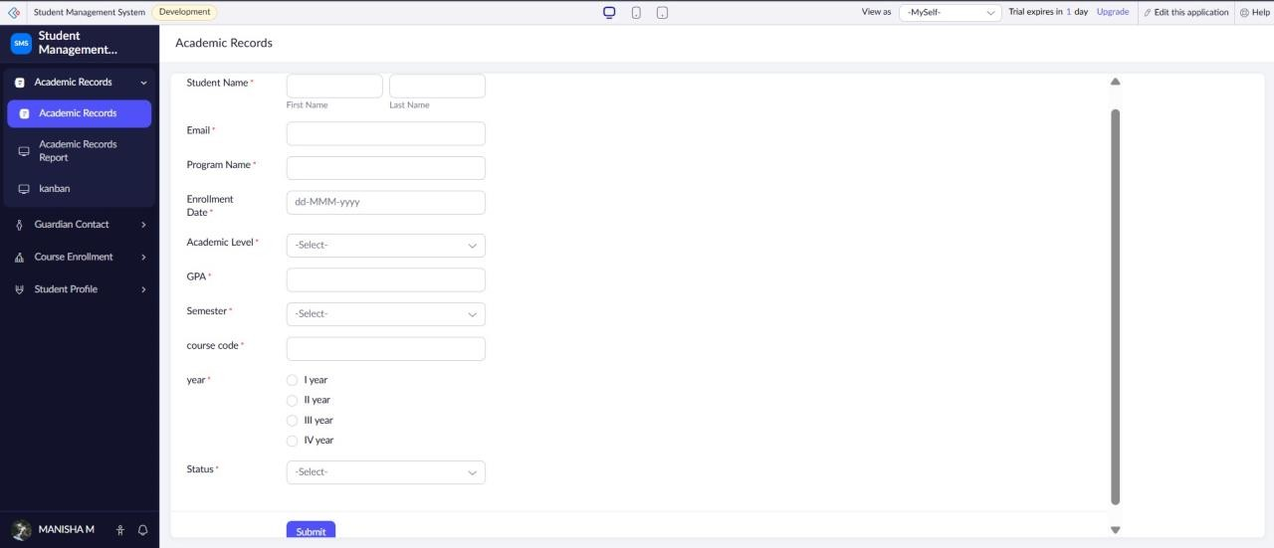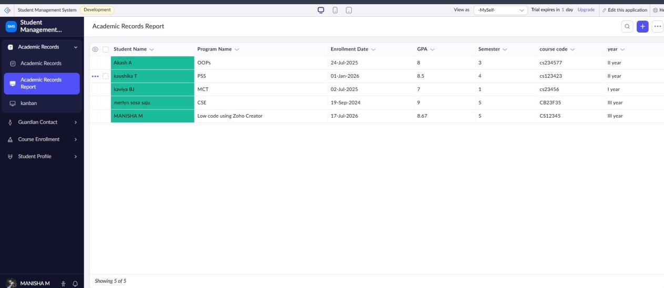

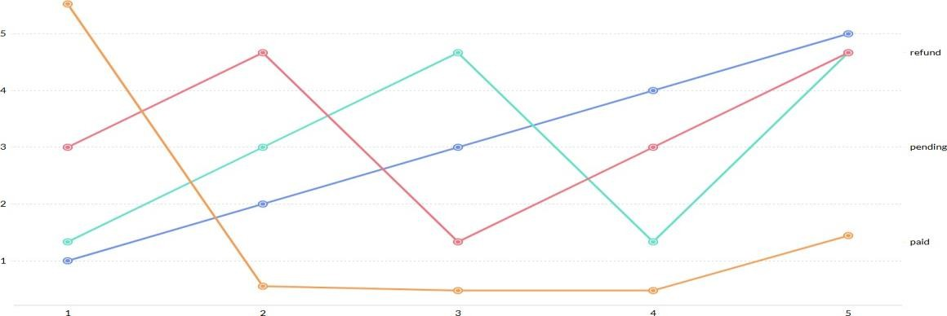

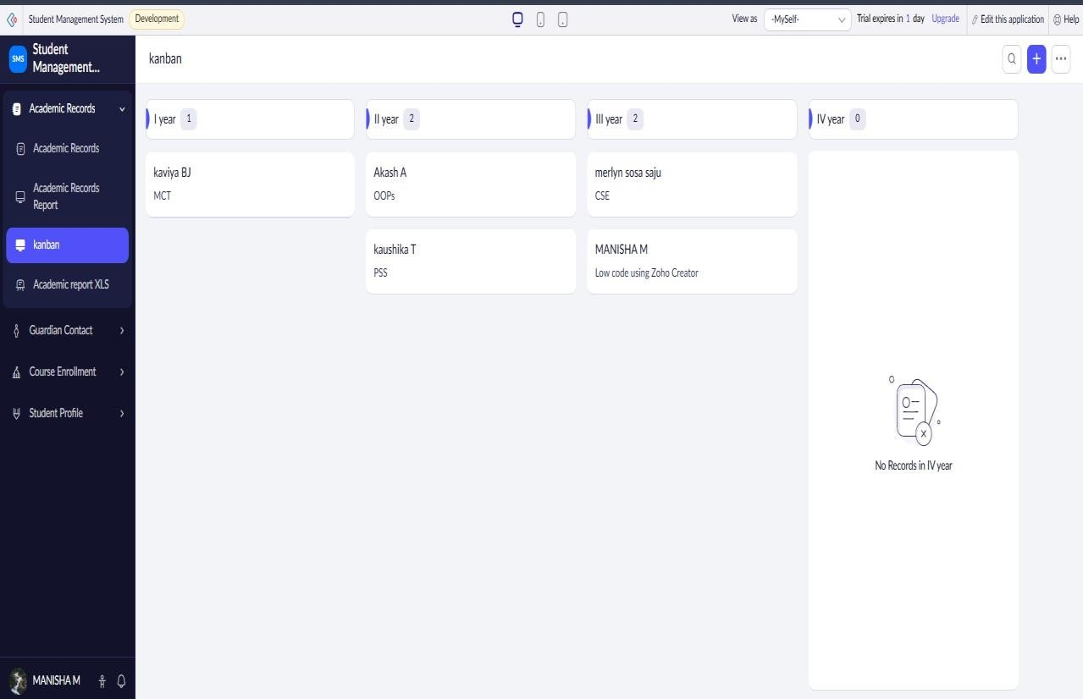
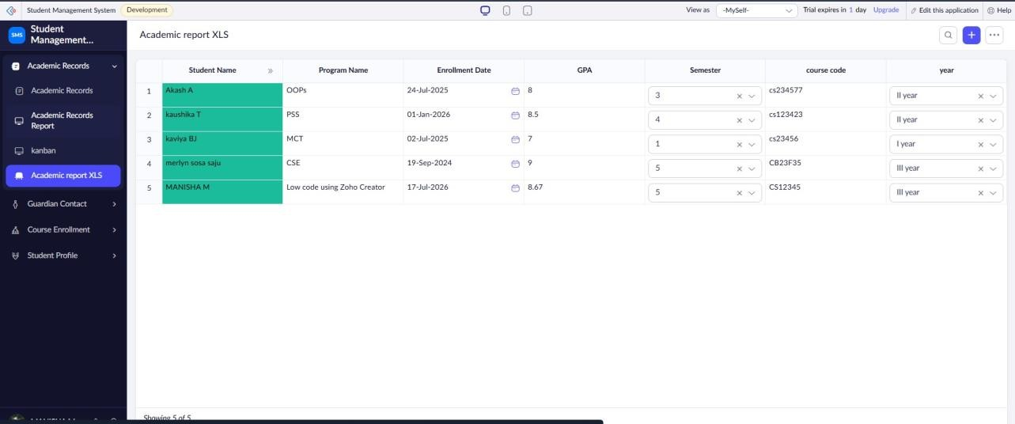

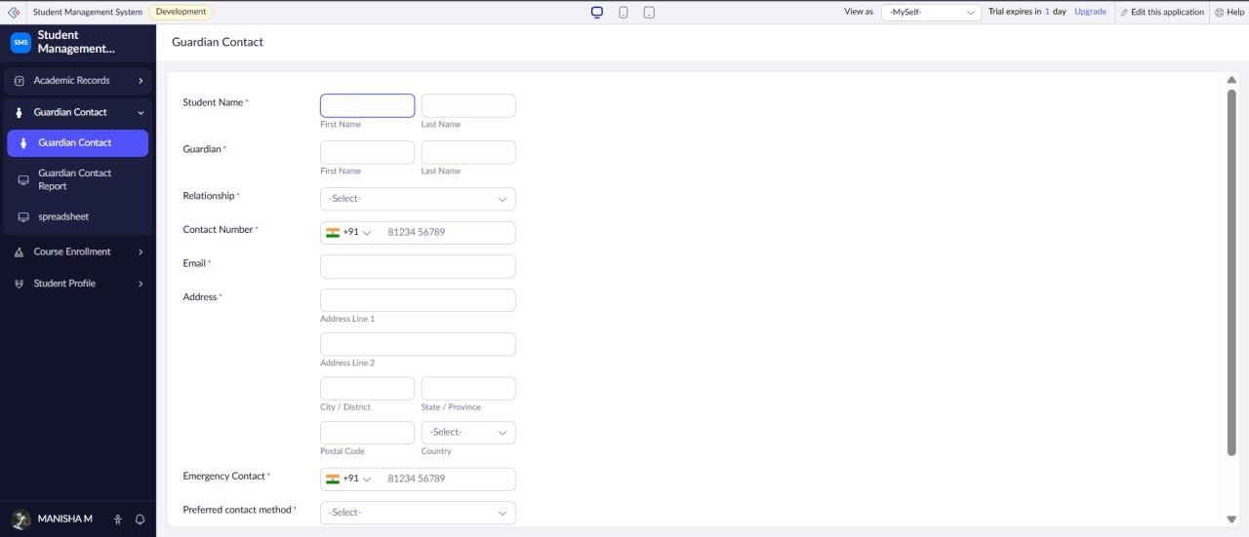

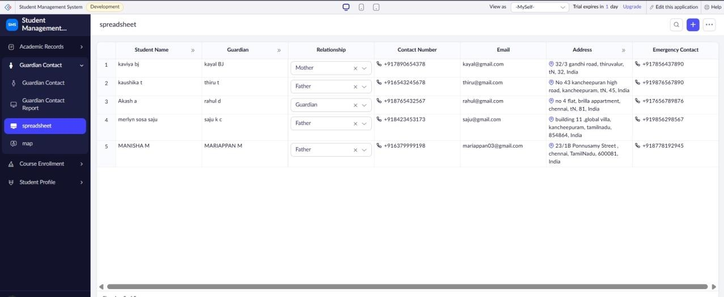
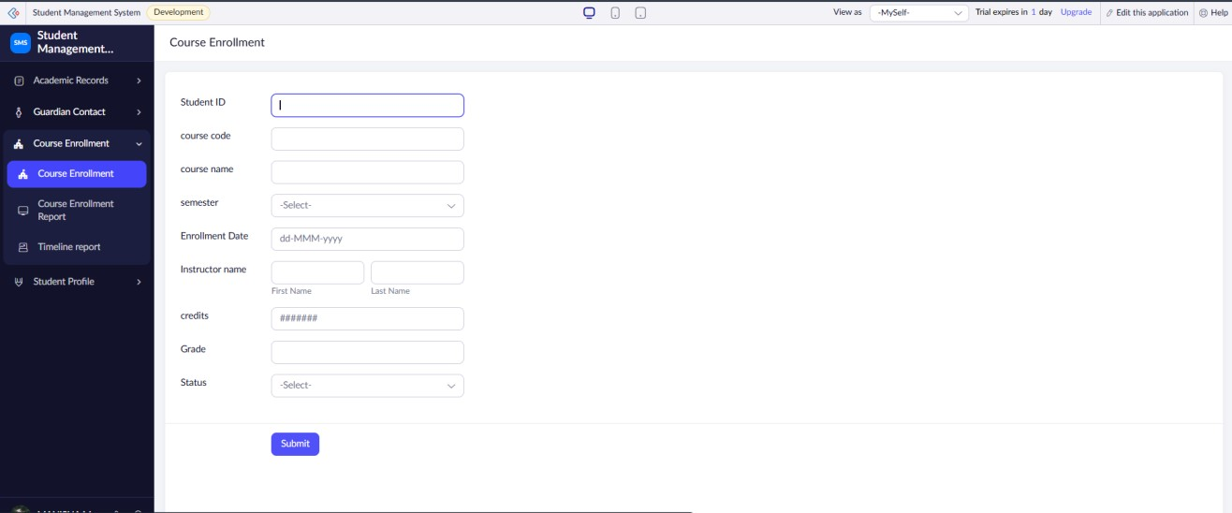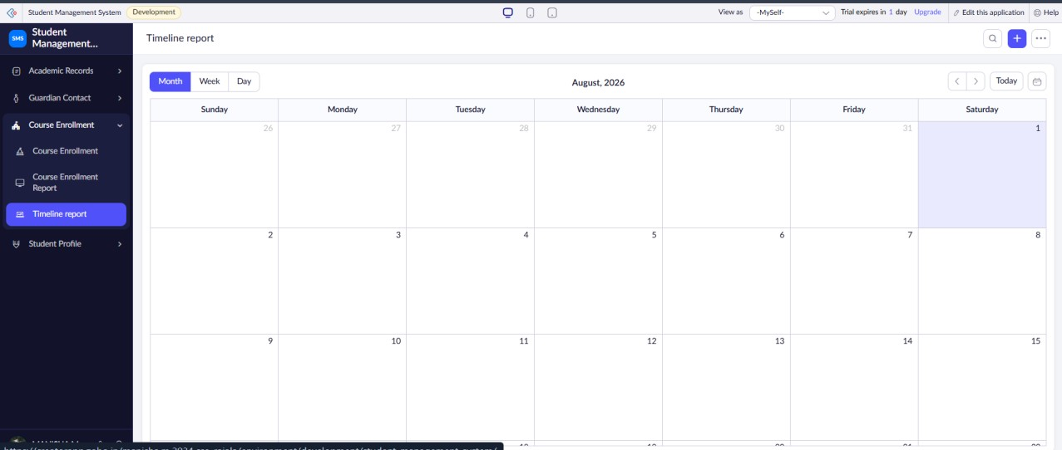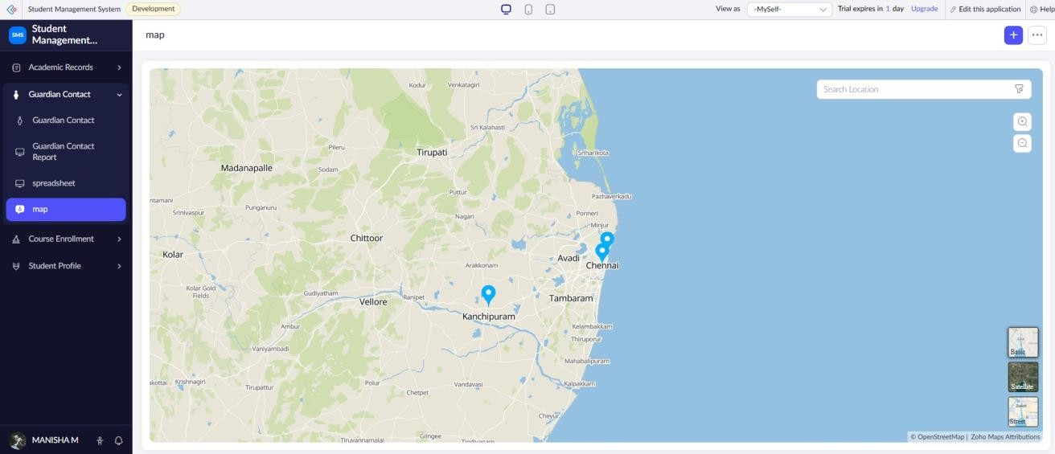
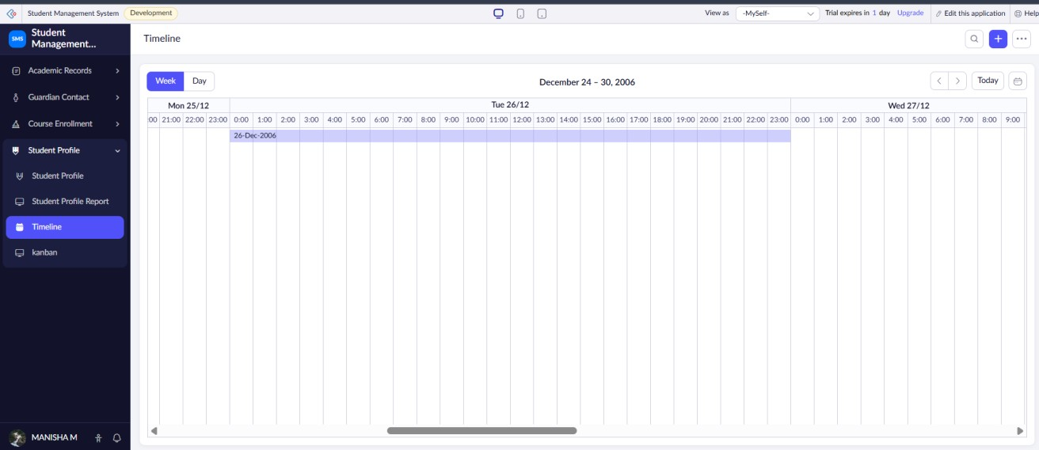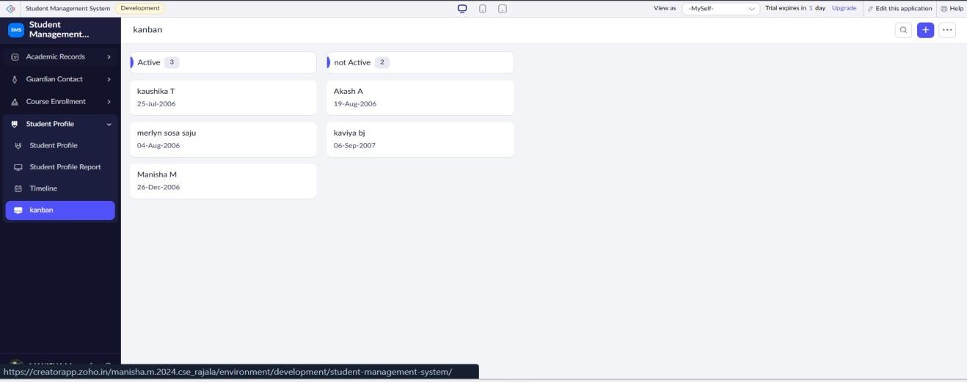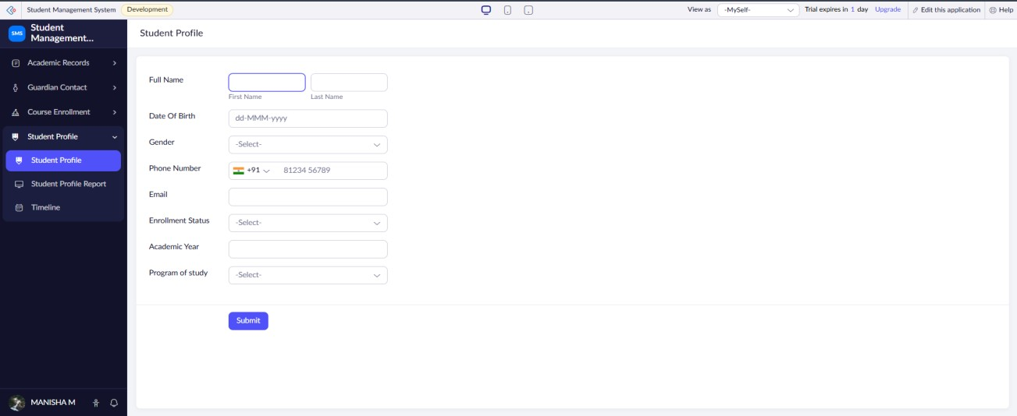

RESULT: Thus, different reports were successfully created from the Student Profile, Academic, Guardian Contact, and Course Enrollment forms in Zoho Creator for effective viewing and analysis of student information.

